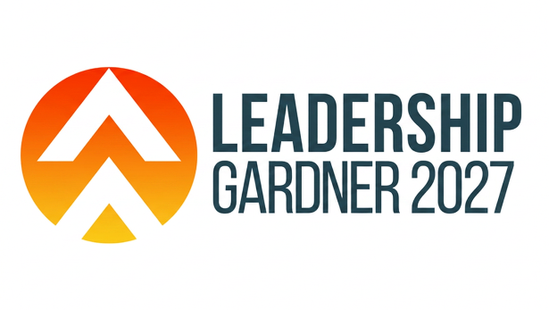
Leadership Gardner is a leadership program designed to strengthen the community by cultivating knowledgeable leaders. Through this 9-session program, participants will be submerged into the workings of a community and learn about city, county, state and regional assets. Participants will gain exposure to business, nonprofit and elected leaders and take a deep dive into civic engagement.
To be considered for Leadership Gardner, candidates must have a desire to engage in the community and commit to the time required to complete the program. Please review the tentative 2027 session schedule. Applicants must complete the following application in its entirety to be considered for participation. Applications are due no later than Friday, December 4, 2026. Candidates will be announced by Friday, December 11, 2026.

CONTACT INFORMATION
Last Name: First Name: Preferred First Name:
Home Address:
Email: Cell Phone:

EMPLOYMENT INFORMATION
Present Employer: Position/Title:
Business Address:
Business Email: Business Phone:
Preferred Email for Correspondence:

EDUCATION INFORMATION
Highest Level Completed: ☐High School or equivalent ☐Associate’s Degree☐Bachelor’s Degree ☐Master’s Degree ☐Doctoral/Professional Degree
Military Service? ☐Yes ☐No If yes, please specify:
How did you hear about Leadership Gardner?

What motivated you to apply for Leadership Gardner and what do you hope to gain? (approx. 200-word limit)

COMMUNITY INVOLVEMENT
List any political, social, civic or religious organizations in which you are currently active. (approx. 200-word limit)

What are some of the greatest attributes of the Gardner community? (approx. 200-word limit)

What are the greatest challenges facing the Gardner community? (approx. 200-word limit)

What would it look like if progress was made on these issues? (approx. 200-word limit)

REFERENCES
Please list three personal, professional or community references:

Name Phone Email

Name Phone Email

Name Phone Email

TUITION
Tuition for chamber members is $900. Tuition for non-members is $1000. For non-members, the additional $100 will be applied toward membership dues should your company join the chamber.) Tuition covers all materials, group transportation, meals, snacks, and graduation luncheon.
*DO NOT SEND TUITION WITH APPLICATION*
Partial scholarships may be available on a limited basis for Gardner Chamber members. Please indicate if you are interested in scholarship assistance.
☐Yes, please consider me for a scholarship.
Please indicate reason for requesting scholarship:

Please list any food allergies or other required accommodations:

APPLICANT SIGNATURE
With my signature, I acknowledge all statements are accurate and true. I understand the purpose of Leadership Gardner and if selected I will devote the time and resources necessary to complete the program. I further understand attendance is mandatory. I will pay in full or make payment arrangements by January 31, 2027.

Signature of Applicant: Date:
(I understand that typing my name constitutes my signature confirming that I acknowledge and agree to the above terms)

EMPLOYER SIGNATURE
As the applicant’s employer, I will support his/her participation in the 2027 Leadership Gardner program by assuring that this applicant can attend each session. I understand all sessions are mandatory and will give him/her time to attend these sessions.

Signature of Employer: Date:
Phone: Email:
(I understand that typing my name constitutes my signature confirming that I acknowledge and agree to the above terms)
Your completed application must be received at the Chamber office by Friday, December 4, 2026.
Return to:
Gardner Chamber of Commerce
Attn: Leadership Gardner
P.O. Box 402
Gardner, KS 66030
913-856-6464
info@gardnerchamber.com

SESSION DATES
(Session dates are tentative and subject to change)
January 7th – Welcome Reception at KC Wine Co
January 13th – Session #1 (Intro to Leadership)
January 29th – Session #2 (Education)
February 9th – Session #3 (City)
February 24th– Session #4 (Health and Human Services)
March 2nd – Session #5 (State)
March 23rd – Session #6 (Public Safety)
April 6th – Session #7 (County)
April 20th - Session #8 (Regionalism)
May 11th – Session #9 (Leading Beyond the Program)
June 9th – Graduation Luncheon

